

Course Project Report
Subject: SWD392

– Da Nang, April 2025 –

Table of Contents
Record of Changes 3
I. Overview 4
I.1 Project Information 4
I.2 Project Team 4
II. Requirement Specification 4
II.1 Problem description 4
II.2 Major Features 4
II.3 Context Diagram 4
II.4 Nonfunction Requirements 5
II.5 Functional requirements 5
II.5.1 Actors 5
II.5.2 Use Cases 5
II.5.2 .1 Diagram(s) 5
II.5.2.2 Use case descriptions 6
II.5.3 Activity diagram 8
III. Analysis models. 9
III.1 Interaction diagrams 9
III.2 State diagram 10
IV. Design specification 11
IV.1 Integrated Communication Diagrams 11
IV.2 System High-Level Design 11
IV.3 Component and Package Diagram 11
IV.4 Class diagram 12
IV.5 Database Design 12
V. Implementation 13
V.1 Map architecture to the structure of the project 13
V.2 Map Class Diagram and Interaction Diagram to Code 13
V. Applying Alternative Architecture Patterns 13
V.1 Applying the service-oriented architecture 13
V.2 Applying Service Discovery Pattern in the service-oriented architecture 13

Record of Changes
Date | A*  M, D | In charge | Change Description
*A - Added M - Modified D - Deleted

I. Overview

I.1 Project Information
- Project name: << Cafeteria Ordering System>>
- Project code: <<COS>>
- Group name: <<SWD392-G1>>
- Software type: <<Software Type: Web, Mobile App,..>>

I.2 Project Team
Full Name | Role | Email | Mobile
 | Lecturer
 | Leader
Lê Thị Bảo Uyên | Member | Uyenltbde180515@fpt.edu.vn | 0366078587
 | Member
 | Member
 | Member

II. Requirement Specification

II.1 Problem description
The Motorbike Rental Management System is a web-based platform developed to modernize and simplify the traditional motorbike rental process. Currently, many rental shops still manage bookings manually through phone calls, messaging applications, or paper records. This leads to several problems such as booking conflicts, inaccurate vehicle availability, difficulty in tracking rental history, delayed customer support, and inefficient business management.
The proposed system provides an online platform that allows customers to search for available motorbikes, compare prices, make reservations, complete payments, and track rental status conveniently. At the same time, rental shop administrators can manage vehicles, customer information, bookings, payments, maintenance schedules, and reports in a centralized system.
The system also improves customer experience by integrating smart features such as online payments, digital contracts, rental reminders, real-time availability updates, customer reviews, and GPS-supported vehicle tracking.
The context diagram below illustrates the interactions between the Motorbike Rental Management System and external entities including customers, administrators, payment gateways, notification services, and GPS tracking services.

External Entities
- Customer
- Administrator
- Rental Staff
- Payment Gateway
- Email/SMS Notification Service
- GPS Tracking Service

Main Data Flows
- Booking requests and confirmations
- Payment transactions
- Vehicle information updates
- Customer registration and authentication
- Rental notifications and reminders
- GPS location tracking data

II.2 Major Features

FE-01: User Registration and Authentication
Customers can register accounts, log in securely, reset passwords, and manage personal profiles.

FE-02: Motorbike Search and Booking
Customers can search available motorbikes based on type, location, price, brand, or rental duration and make reservations online.

FE-03: Online Payment Integration
The system supports secure online payment methods such as banking, e-wallets, and QR payments.

FE-04: Rental Order Management
Customers can create, view, modify, or cancel rental orders.

FE-05: Vehicle Management
Administrators can add, edit, delete, and manage motorbike information including status, pricing, maintenance history, and images.

FE-06: GPS Tracking and Vehicle Monitoring
The system supports GPS integration to help track rented motorbikes and improve security.

FE-07: Notification and Reminder System
Customers receive booking confirmations, payment receipts, rental reminders, and return notifications through email or SMS.

FE-08: Review and Rating System
Customers can rate motorbikes and leave feedback after completing rentals.

FE-09: Reporting and Analytics
Administrators can generate reports related to revenue, bookings, vehicle usage, and customer activity.

FE-10: Maintenance Management
The system tracks vehicle maintenance schedules and alerts administrators when maintenance is required.

II.3 Context Diagram

System: Motorbike Rental Management System

External Entities and Interactions
External Entity | Input to System | Output from System
Customer | Registration data, booking requests, payments, reviews | Booking confirmation, payment status, notifications
Administrator | Vehicle updates, pricing updates, report requests | Business reports, customer information
Rental Staff | Rental status updates, maintenance records | Rental schedules, customer booking details
Payment Gateway | Payment verification | Payment requests
Notification Service | Notification delivery status | Emails, SMS reminders
GPS Tracking Service | GPS location data | Tracking requests

Context Diagram Description
The Motorbike Rental Management System acts as the central platform connecting customers, administrators, staff, payment services, and GPS services. Customers interact with the system to search, book, and pay for rentals. Administrators and staff manage operational activities while external services support payments, notifications, and tracking.

II.4 Nonfunctional requirements
# | Feature | System Function | Description
1 | Authentication | Login Service | Validate user credentials securely using encrypted passwords and session management.
2 | Booking Management | Booking API | Handle booking requests and ensure real-time vehicle availability updates.
3 | Payment Processing | Payment Gateway Integration | Process secure online transactions and payment verification.
4 | Notification System | Email/SMS Service | Automatically send booking confirmations and reminders.
5 | GPS Tracking | Vehicle Tracking Service | Track vehicle locations in real time for security purposes.
6 | Reporting | Report Generation Service | Generate monthly revenue and booking statistics.
7 | Maintenance | Maintenance Scheduler | Automatically remind administrators about vehicle maintenance schedules.
8 | Performance | Load Handling | Support multiple concurrent users without major performance degradation.
9 | Security | Data Protection | Protect user information and transaction data using encryption and authentication mechanisms.
10 | Backup | Data Backup Service | Automatically back up system data daily to prevent data loss.

II.5 Functional requirements

II.5.1 Actors
# | Actor | Description
1 | Guest | Unregistered user who can browse the website, search motorbikes, and view vehicle information without logging in.
2 | Customer | Registered user who can book motorbikes, make payments, manage bookings, and submit reviews.
3 | Admin | Manages the entire system including users, vehicles, reports, and platform settings. Admin is a specialized role of Customer.
4 | Owner | Manages rental shop information, motorbike inventory, pricing, and rental operations. Owner is a specialized role of Customer.
5 | Staff | Supports daily rental activities such as confirming bookings, checking vehicle conditions, and handling returns. Staff is a specialized role of Customer.

II.5.2 Use Cases

Guest Use Cases
- Register Account
- Login
- Search Motorbike
- View Motorbike Details
- View Rental Prices

Customer Use Cases
- Manage Profile
- Book Motorbike
- Make Payment
- View Booking History
- Cancel Booking
- Submit Review
- Receive Notifications

Admin Use Cases
- Manage Users
- Manage System Settings
- Manage Reports
- Monitor Activities
- Manage Categories

Owner Use Cases
- Manage Motorbike Inventory
- Approve Booking Requests
- Manage Maintenance Schedule
- View Revenue Reports

Staff Use Cases
- Confirm Booking
- Deliver Motorbike
- Receive Returned Vehicle
- Update Rental Status
- Support Customers

II.5.2 .1 Diagram(s)

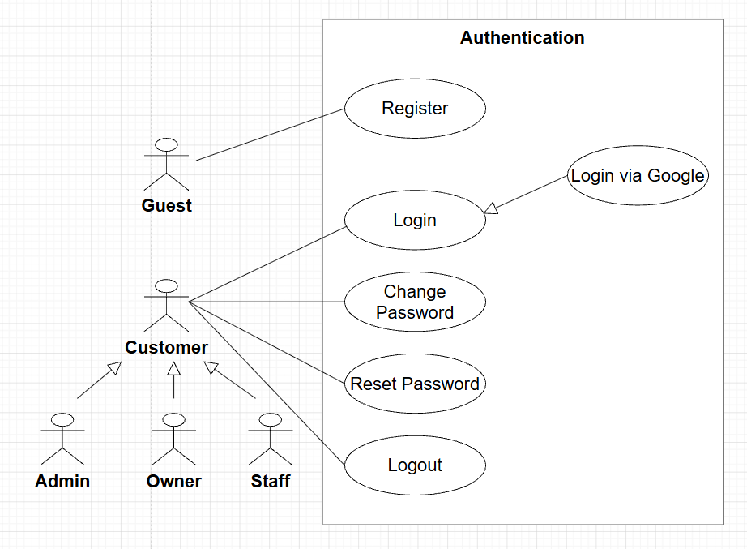
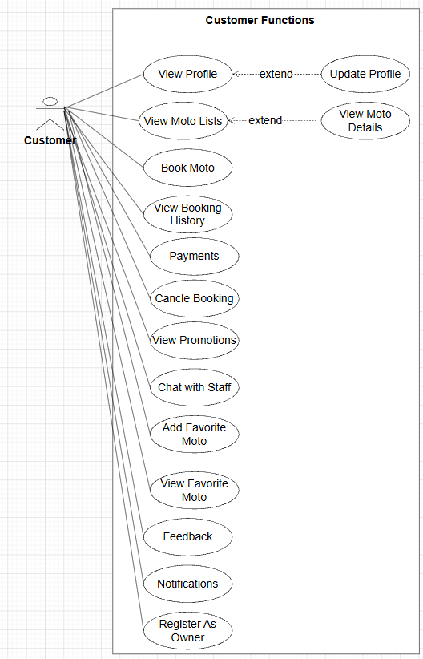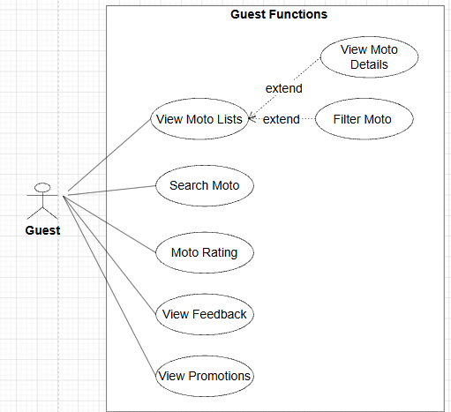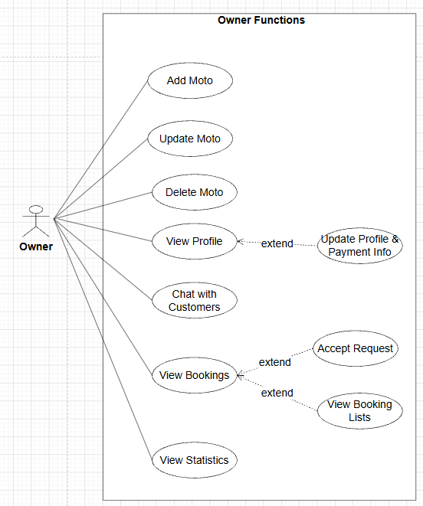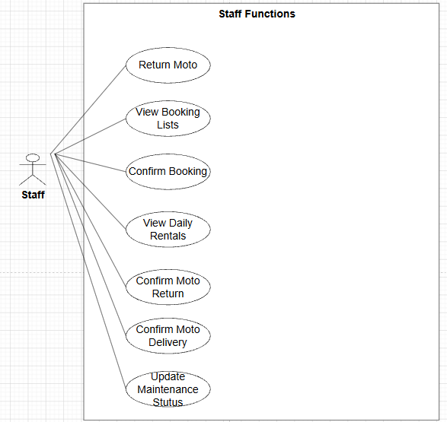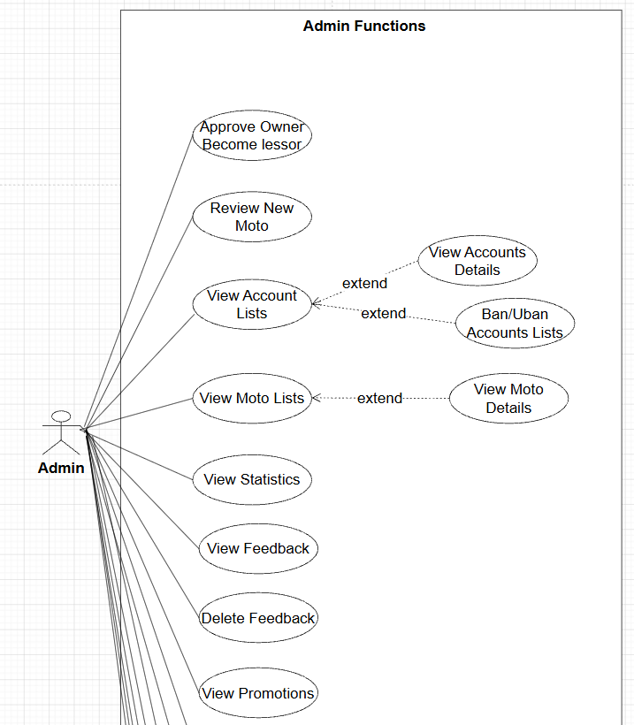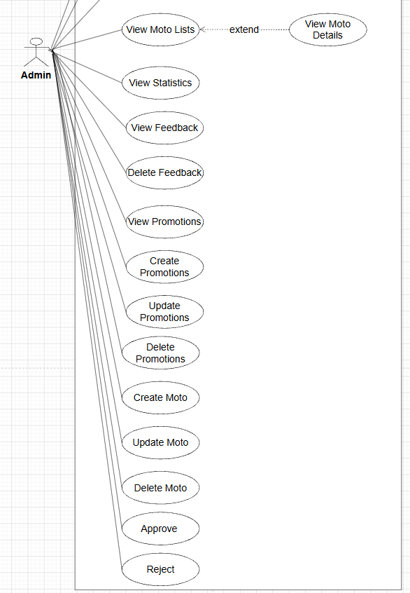

II.5.2.2 Use case descriptions
This part describes the use cases, you can follow the table form as below]
ID | Use Case | Actors | Use Case Description
UC-01 | Register Account | Guest | Guest creates a new account to access the rental system.
UC-02 | Login | Guest, Customer, Admin, Owner, Staff | Users authenticate and access system functions based on their roles.
UC-03 | Search Motorbike | Guest, Customer | Users search motorbikes by category, price, location, or availability.
UC-04 | View Motorbike Details | Guest, Customer | Users view detailed information, images, and rental prices of motorbikes.
UC-05 | Book Motorbike | Customer | Customer books a motorbike for a selected rental duration.
UC-06 | Make Payment | Customer | Customer pays rental fees through supported online payment methods.
UC-07 | Cancel Booking | Customer | Customer cancels an existing booking before the rental start time.
UC-08 | Submit Review | Customer | Customer rates and reviews completed rental services.
UC-09 | Manage Users | Admin | Admin manages user accounts, permissions, and account status.
UC-10 | Manage Reports | Admin | Admin monitors business reports and system statistics.
UC-11 | Manage Categories | Admin | Admin manages motorbike categories and rental policies.
UC-12 | Manage Motorbike Inventory | Owner | Owner adds, edits, deletes, and updates motorbike information.
UC-13 | Approve Booking Requests | Owner | Owner reviews and approves customer rental requests.
UC-14 | Manage Maintenance Schedule | Owner | Owner manages vehicle maintenance and repair schedules.
UC-15 | View Revenue Reports | Owner | Owner tracks rental income and booking performance.
UC-16 | Confirm Booking | Staff | Staff verifies customer booking information before rental delivery.
UC-17 | Deliver Motorbike | Staff | Staff hands over the motorbike to the customer.
UC-18 | Receive Returned Vehicle | Staff | Staff checks vehicle condition when customers return motorbikes.
UC-19 | Update Rental Status | Staff | Staff updates rental progress and vehicle availability status.
UC-20 | Support Customers | Staff | Staff assists customers during the rental process.

1 <<UseCaseCode_UC Name>>
Functional Description Template
UC ID and Name:
Created By: |  | Date Created:
Primary Actor: |  | Secondary Actors:
Trigger:
Description:
Preconditions:
Postconditions:
Normal Flow:
Alternative Flows:
Exceptions:
Priority: | High (Medium, Low), Must Have (Should Have, Could Have),..
Frequency of Use:
Business Rules:
Other Information:
Assumptions:

Functional Description Contents
Use Case ID and Name
Give each use case a unique integer sequence number identifier. State a concise name for the use case that indicates the value the use case would provide to some user. Begin with an action verb, followed by an object.
Author and Date Created
Enter the name of the person who initially wrote this use case and the date it was written.
Primary and Secondary Actors
An actor is a person or other entity external to the software system being specified who interacts with the system and performs use cases to accomplish tasks. Different actors often correspond to different user classes, or roles, identified from the customer community that will use the product. Name the primary actor that will be initiating this use case and any other secondary actors who will participate in completing execution of the use case.
Trigger
Identify the business event, system event, or user action that initiates the use case. This trigger alerts the system that it should begin testing the preconditions for the use case so it can judge whether to proceed with execution.
Description
Provide a brief description of the reason for and outcome of this use case, or a high-level description of the sequence of actions and the outcome of executing the use case.
Preconditions
List any activities that must take place, or any conditions that must be true, before the use case can be started. The system must be able to test each precondition. Number each precondition. Example: PRE-1: User’s identity has been authenticated.
Postconditions
Describe the state of the system at the successful conclusion of the use case execution. Label each postcondition in the form POST-X, where X is a sequence number. Example: POST-1: Price of item in the database has been updated with the new value.
Normal Flow
Provide a description of the user actions and corresponding system responses that will take place during execution of the use case under normal, expected conditions. This dialog sequence will ultimately lead to accomplishing the goal stated in the use case name and description. Show a numbered list of actions performed by the actor, alternating with responses provided by the system. The normal flow is numbered “X.0”, where “X” is the Use Case ID.
Alternative Flows
Document other successful usage scenarios that can take place within this use case. State the alternative flow, and describe any differences in the sequence of steps that take place. Number each alternative flow in the form “X.Y”, where “X” is the Use Case ID and Y is a sequence number for the alternative flow. For example, “5.3” would indicate the third alternative flow for use case number 5. Indicate where each alternative flow would branch off from the normal flow, and if pertinent, where it would rejoin the normal flow.
Exceptions
Describe any anticipated error conditions that could occur during execution of the use case and how the system is to respond to those conditions. Number each alternative flow in the form “X.Y.EZ”, where “X” is the Use Case ID, Y indicates the normal (0) or alternative (>0) flow during which this exception could take place, “E” indicates an exception, and “Z” is a sequence number for the exceptions. For example “5.0.E2” would indicate the second exception for the normal flow for use case number 5. Indicate where in the normal (or an alternative) flow each exception could occur.
Priority
Indicate the relative priority of implementing the functionality required to allow this use case to be executed. Use the same priority scheme as that used for the functional requirements.
Frequency of Use
Estimate the number of times this use case will be performed per some appropriate unit of time. This gives an early indicator of throughput, concurrent usage loads, and transaction capacity.
Business Rules
List any business rules that influence this use case. Don’t include the business rule text here, just its identifier so the reader can find it in another repository when needed.
Other Information
Identify any additional requirements, such as quality attributes, for the use case that may need to be addressed during design or implementation. Also list any associated functional requirements that aren’t a direct part of the use case flows but which a developer needs to know about. Describe what should happen if the use case execution fails for some unanticipated or systemic reason (e.g., loss of network connectivity, timeout). If the use case results in a durable state change in a database or the outside world, state whether the change is rolled back, completed correctly, partially completed with a known state, or left in an undetermined state as a result of the exception.
Assumptions
List any assumptions that were made regarding this use case or how it might execute.

b. Business Rules
Provide the business rules those are applied only to the use case
ID | Business Rule | Business Rule Description
FR1 | Password Encoding | User’s password must be encoded with MD5 hashing

II.5.3 Activity diagram
[This part describes the use cases, you can follow the table form as below]
Sample:
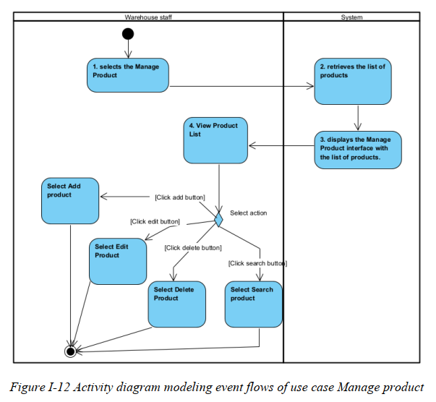
………

II.6 Entity Relationship Diagram
[Provide the entity relationship diagram and the entity descriptions in the table format as below]

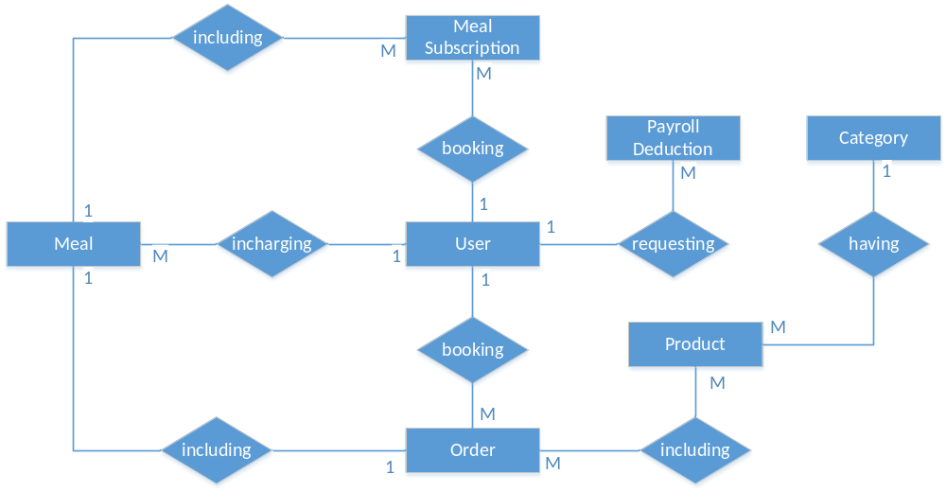

III. Analysis models.

III.1 Interaction diagrams
[Interaction diagrams are a type of UML diagram that illustrate how objects interact in a particular scenario of a use case. They focus on the flow of messages between objects or components over time.
There are two main types:
- Sequence Diagram – Emphasizes the time-ordering of messages
- Communication Diagram – Emphasizes the structure and relationships between objects]

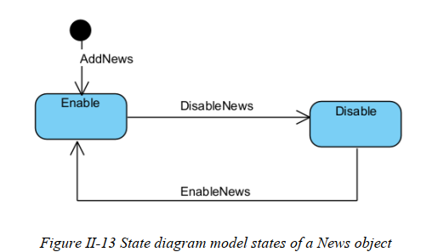

IV. Design specification

IV.1 Integrated Communication Diagrams
Sample
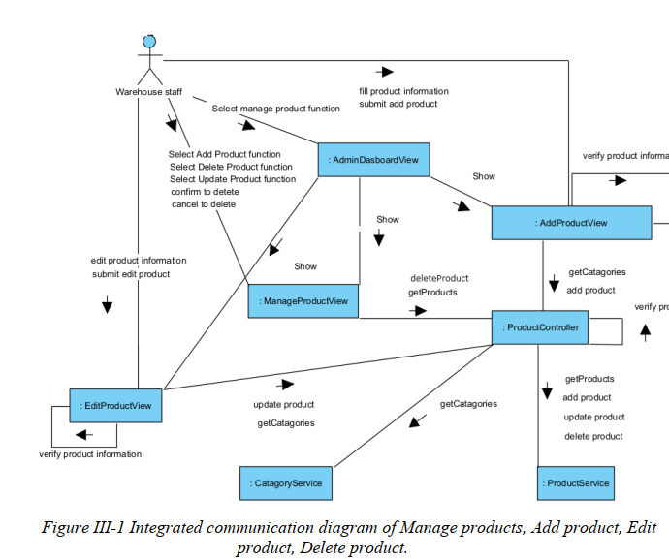

IV.2 System High-Level Design
Sample
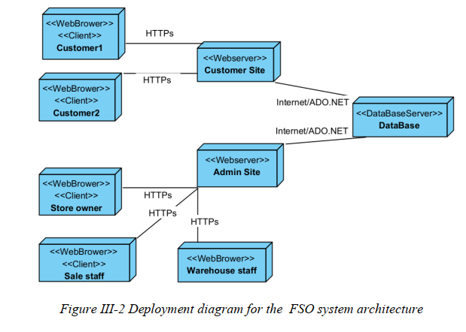

IV.3 Component and Package Diagram

IV.3.1 Component Diagram
Sample
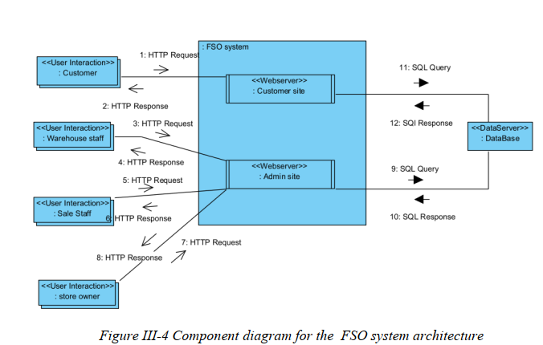

IV.3.1 . Package Diagram
[Provide the package diagram for each sub-system. The content of this section including the overall package diagram, the explanation, package and class naming conventions in each package. Please see the sample & description table format below (please note: package names don’t follow Java package naming convention yet)]
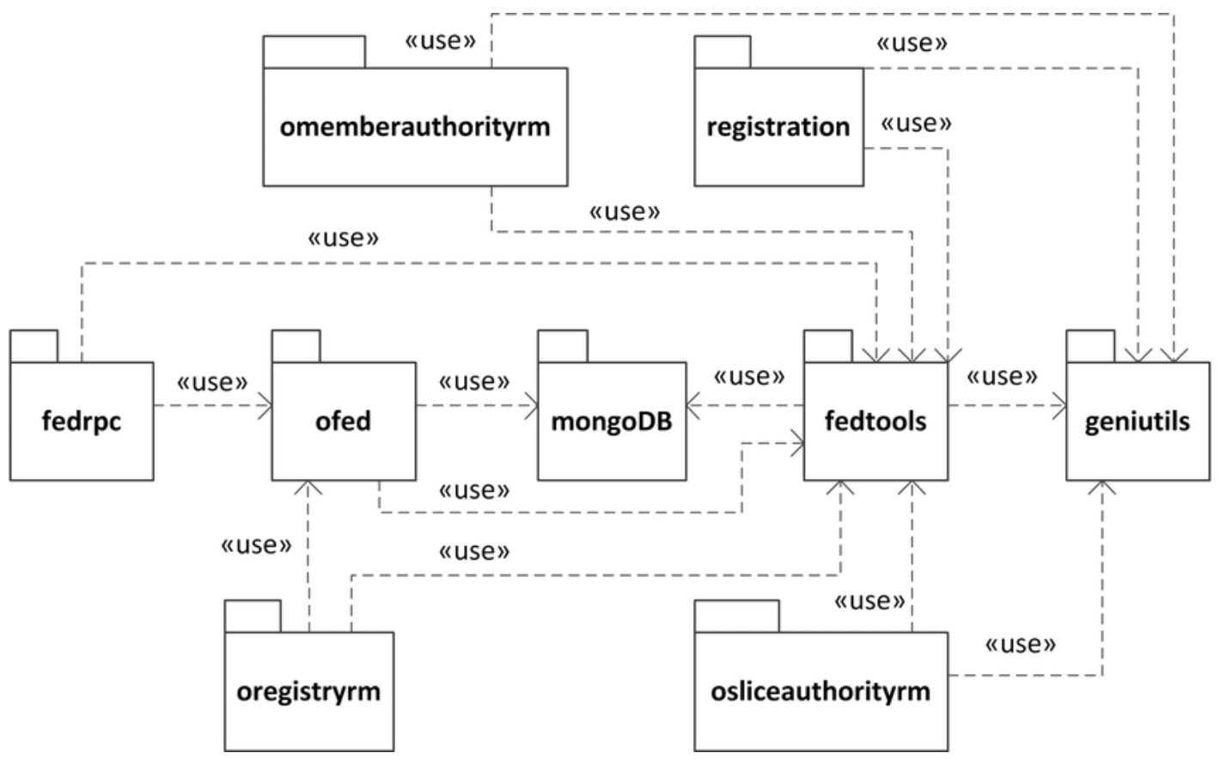
Package descriptions
No | Package | Description
01 | omemberauthorityrm | <Description of the package>
02 | registration | <Description of the package>
03 | fedrpc | <Description of the package>
04 | ofed | <Description of the package>
05 | mongoDB | <Description of the package>
06 | fedtools | <Description of the package>
07 | …

IV.4 Class diagram
[This part presents the class diagram for the relevant feature]
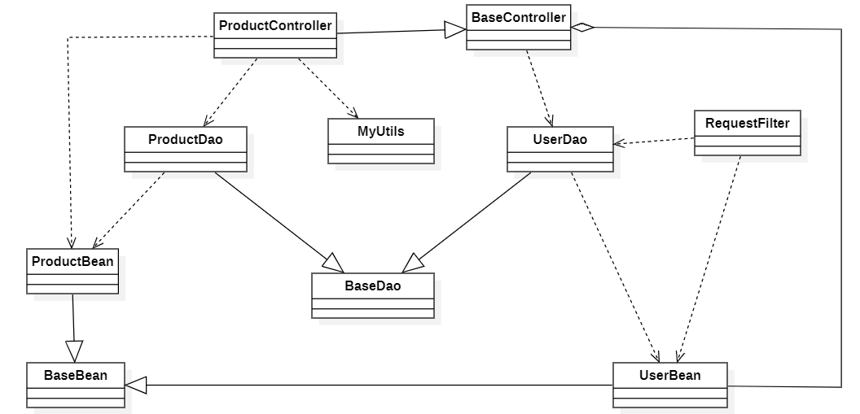

III.1.1.Sequence Diagram

[Provide the sequence diagram(s) for the feature, see the sample below]
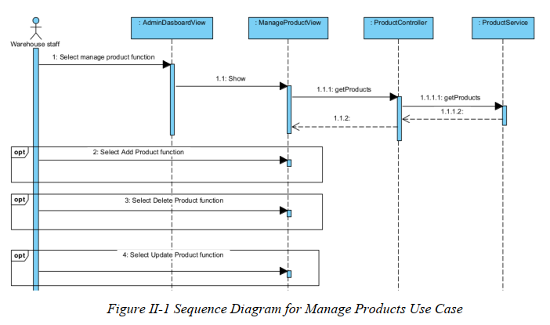

III.1.2. Communication Diagram
[Provide the Communication diagram(s) for the feature, see the sample below]

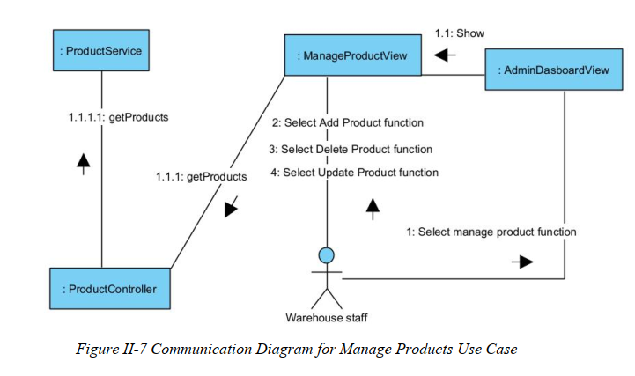

III.2 State diagram
[Provide the State diagram(s) for the feature, see the sample below]

IV.5 Database Design
[Provide the tables relationship like example below – following MySQL database naming convention]

V. Implementation

V.1 Map architecture to the structure of the project
[Provide:
- Overview of the Chosen Architecture
Briefly describe the architectural style (e.g., Layered, MVC, Service-Oriented Architecture)
Explain why it was selected for this project (e.g., to meet non-functional requirements like maintainability, scalability, reusability)
- Mapping to Project Structure
Present the actual project folder/package structure
Map each layer/component in the architecture to concrete project modules]

V.2 Map Class Diagram and Interaction Diagram to Code
[Demo the implementation of several features using design patterns]

VI. Applying Alternative Architecture Patterns

VI.1 Applying the ………….. (ex: Service-Oriented Architecture (SOA)) architecture
[Redesign part of the system architecture using Service-Oriented Architecture (SOA) to improve reusability, scalability, and modularity.
Students must provide:
- Problem Identification
Briefly describe which non-functional requirement(s) are not fully supported by the current architecture (e.g., NF-05: Reusability)
- SOA-Based Solution
Reorganize system components into independent services
E.g., refactor FSOData into separate service modules
- Supporting Diagrams
Deployment Diagram
Updated Class Diagram
Component Diagram showing separate services]

VI.2 Applying Service Discovery Pattern in the service-oriented architecture
[Support dynamic service registration and discovery in SOA or microservice-based architecture for horizontal scalability and ease of expansion.
Students must provide:
- Problem & Requirement
Explain the relevant non-functional requirement (e.g., NF-06: Scalability)
Describe the need for service discovery in a growing system (e.g., multiple branches, independent modules)
- Service Discovery-Based Solution
Integrate a Service Discovery Pattern
Mention possible technologies: Consul, Eureka, Kubernetes DNS
- Supporting Diagrams
Deployment Diagram (with multiple instances and registry)
Updated Class/Component Diagram including a Discovery Service]

